Sydney Western City Planning Panel Assessment Report
6 September 2021

Panel Reference | PPSSWC-106
DA Number | S960074/20
LGA | Hawkesbury City Council
Proposed Development | Modification of Development Consent - DA0820/15 - Intensive Plant Agriculture - Construction of growing rooms associated internal access roads, drainage, dam and tree removal
Street Address | 182 Boundary Road GLOSSODIA NSW 2756  Legal Description: Lot 12 DP 1256826 (Formerly Lot 1 and 2 in DP 603811.)
Applicant | Premier Mushrooms Pty Ltd
Owner | Premier Mushrooms Pty Ltd
Date of DA Lodgement | 04/09/2020
Number of Submissions | Four (4)
Recommendation | Approval
Regional Development Criteria (Schedule 7 of the State and Regional Development SEPP) | The capital investment value for the modified proposal is $27,781,735.00  The application was determined when applications >$20 million were identified as regionally significant development. In March 2018 regionally significant development was increased from >$20 million to >$30 million.  The original application was determined by the planning panel and Clause 123BA of the Environmental Planning and Assessment Regulation 2000 does not allow Council to modify an application determined by the panel pursuant to 4.55(2) of the Act.  The original consent approved a variation to the 10 metre building height development standard greater than 10%.
List of all relevant Section 4.15 matters | - List of the relevant environmental planning instruments under Section 4.15(1)(a)(i):  - State Environmental Planning Policy (State and Regional Development) 2011 (SRD SEPP);  - State Environmental Planning Policy (Coastal Management) 2018 (Coastal Management SEPP);  - State Environmental Planning Policy No. 33 – Hazardous and Offensive Development (SEPP No. 33);  - State Environmental Planning Policy No. 55 – Remediation of Land (SEPP No. 55);  - State Environmental Planning Policy 2021 (Koala Habitat Protection);  - Sydney Regional Environmental Plan No. 20 – Hawkesbury-Nepean River (SREP No. 20);  - Hawkesbury Local Environmental Plan 2012 (LEP).  - List any proposed instrument that is or has been the subject of public consultation under the Act and that has been notified to the consent authority under Section 4.15(1)(a)(ii):  - Draft State Environmental Planning Policy (Remediation of Land);  - Draft State Environmental Planning Policy (Environment).  - List any relevant development control plan under Section 4.15(1)(a)(iii):  - Hawkesbury Development Control Plan 2002 (DCP).  - List any relevant planning agreement that has been entered into or any draft planning agreement that a developer has offered to enter into under Section 7.4 (Section 4.15(1)(a)(iiia)):  - Not applicable.  - Relevant regulations (Section 4.15(1)(a)(iv))  - Environmental Planning and Assessment Regulation 2000 (EP&A Regulation).
List all documents submitted with this rep0ort for the Panel’s consideration | Refer to plans and documents listed under recommended Condition No. 1 of Attachment 4.
Report prepared by | William Pillon  Senior Town Planner  Hawkesbury City Council
Report date | 19 August 2021
Legislative clauses requiring consent authority satisfaction  Have relevant clauses in all applicable environmental planning instruments where the consent authority must be satisfied about a particular matter been listed, and relevant recommendations summarized, in the Executive Summary of the assessment report?  e.g. Clause 7 of SEPP 55 - Remediation of Land, Clause 4.6(4) of the relevant LEP |  | Yes
Clause 4.6 Exceptions to Development Standards  If a written request for a contravention to a development standard (clause 4.6 of the HLEP) has been received, has it been attached to the assessment report? |  | Not Applicable
Special Infrastructure Contributions  Does the DA require Special Infrastructure Contributions conditions (Section 7.24)?  Note: Certain DAs in the Western Sydney Growth Areas Special Contributions Area may require specific Special Infrastructure Contributions (SIC) conditions |  | Not Applicable

Assessment Report

Executive Summary

Council is in receipt of a modification application which seeks consent for changes to Development Consent No. DA0820/15 which approved Intensive Plant Agriculture - Construction of growing rooms associated internal access roads, drainage, dam and tree removal at 182 Boundary Road Glossodia NSW.

The modifications proposed as part of this application seek to change the overall staging of the development, increase output by 2 tonnes per week on completion of the final stage, addition of a machinery building, change to storage/amenities buildings within the site and an overall reduction in the mushroom growing building.

The application has been assessed against the Environmental Planning and Assessment Act 1979, the Environmental Planning and Assessment Regulation 2000, relevant Environmental Planning Instruments and Hawkesbury Development Control Plan 2002.

The application was advertised and notified in accordance with Hawkesbury Development Control Plan 2002. A total of four submissions have been received raising objection to the proposal based on a number of matters including impacts on adjacent development, traffic, noise, scale of the development, property values, amenity of the locality, landscaping, water runoff and visual appearance. These submissions have been reviewed and it is considered that the issues raised do not warrant refusal of the proposed modifications.

Based on the assessment of the proposal it is recommended that the application be approved subject to the modified consolidated conditions of consent included in Attachment 5 to this report.

Description of the Proposal

The application has been lodged pursuant to Section 4.55 (2) of the Environmental Planning and Assessment Act 1979 (EP&A Act), the consent authority for this Development Application (DA) is the Sydney Western City Planning Panel (SWCPP).

The application seeks approval for Modification of Development Consent No. DA0820/15 which approved Intensive Plant Agriculture - Construction of growing rooms associated internal access roads, drainage, dam and tree removal.

The modification application seeks consent to:
- Modify the staging of the development so that the largest expansion to the mushroom growing buildings occurs as part of stage 3,
- Reduce the overall width and size of the mushroom growing buildings resulting in a reduction in total floor area of 2,814sqm,
- Reduce the maximum building height of the mushroom growing buildings by 1.9m and increase the wall height by 2m.
- Increase production at the completion of stage 3 from 120 to 122 tonnes/per week,
- Increase the cool room storage by 158sqm,
- Modify the approved peat storage areas,
- Add a washroom,
- Relocate the amenities, storage buildings and awnings between the existing buildings,
- Increase the size of the outdoor hardstand area for the temporary storage of spent mushroom compost from the growing rooms,
- Install two concrete water tanks (200,000L) for the buildings static water supply for firefighting purposes, and
- Construct a new 240sqm machinery storage building.

The above changes will result in the removal of six trees to accommodate the new machinery building, change to staffing numbers and production associated with the staging of the development, change in roof form, increase in building setbacks from property boundaries, change in the way stormwater is collected/treated/directed to the water storage facilities, increase in two car parking spaces and a reduction in fill height for stage 3 of the development.

The proposed modification will ultimately upgrade the layout, amenities and servicing within the site and incorporate updated technology within the modified mushroom growing buildings.

Stage 1 and 2 earthworks have already commenced and the consent is taken to have been secured. The approved hours of operation or operational conditions are not proposed to be altered as part of the subject application.

The following figures identify the previously approved layout and proposed layout.

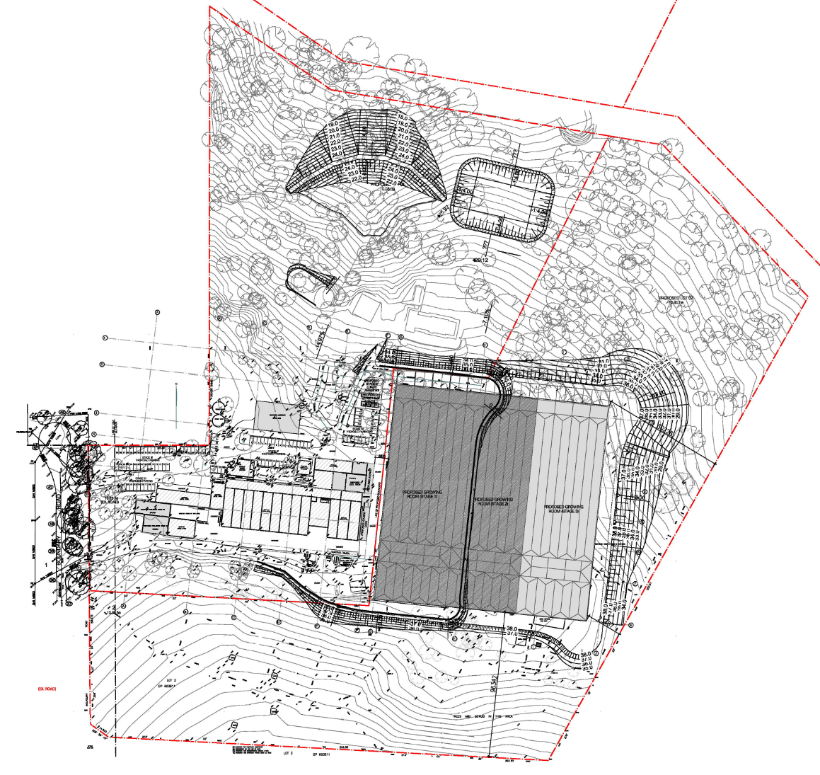
Figure 1: Layout of the approved development on completion of stage 3

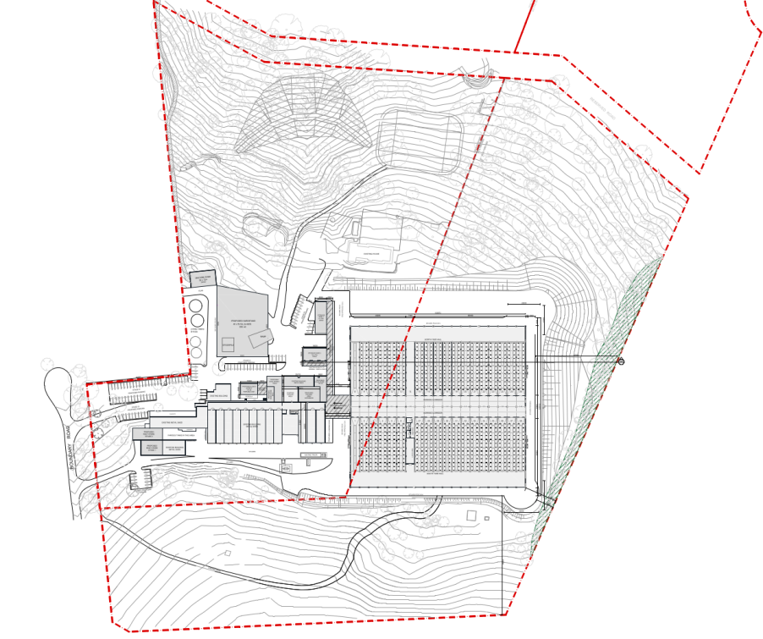
Figure 2: Proposed modified development on completion of stage 3

A copy of the original determination of the application and the approved plans are included as part of Attachment 2 and 3 to this report.

The specifics of existing approved operations and the modified proposal are as follows:

Existing and approved | Modified proposal
Growing room buildings  Existing: 12 mushroom growing rooms totalling approximately 2708square metres in area.  Stage 1: Construction of additional mushroom growing rooms totalling 6669square metres in area.  Stage 2: Construction of additional mushroom growing rooms totalling 6669square metres in area.  Stage 3: Construction of additional mushroom growing rooms totalling 6669square metres in area. | Growing room buildings  Stage 1: Construction of mushroom growing rooms totalling 3206 square metres in area.  Stage 2: Construction of mushroom growing rooms totalling 5904square metres in area.  Stage 3: Construction of mushroom growing rooms totalling 8150 square metres in area.  Total reduction in 2814 square metres in area.
Staff numbers  Existing: 45 staff  Stage 1: additional 26 staff  Stage 2: additional 14 staff  Stage 3: additional 14 staff  Total of 99 staff | Staff numbers  Existing: 45 (to be reduced/combined with stage 1)  Stage 1: additional 3 staff  Stage 2: additional 23 staff  Stage 3: additional 28 staff  Total of 99 staff
Hours of operation  Currently 7 days a week between 6am and 10pm  Approved  6am to 10pm seven days a week with the exception of the use of the property between 10 to 12 midnight for four truck movements only. | Hours of operation  No change.
Mushroom production  Existing: 30 tonnes of mushrooms per week  Stage 1: additional 30 tonnes of mushrooms per week  Stage 2: additional 30 tonnes of mushrooms per week  Stage 3: additional 30 tonnes of mushrooms per week  Total of 120 tonnes of mushrooms per week | Mushroom production  Existing: 30 tonnes of mushrooms per week  (to be reduced to 20)  Stage 1: additional 17 tonnes of mushrooms per week  Stage 2: additional 34 tonnes of mushrooms per week  Stage 3: additional 51 tonnes of mushrooms per week  Total of 122 tonnes of mushrooms per week

Site and Locality Description

The application relates to Lot 12 in DP 1256826 No. 182 Boundary Road Glossodia. (“the land”). The current lot was created as a result of the consolidation of Lot 1 and 2 in DP 603811. The land totals 20.34 hectares in area, is intersected by a road reserve and boarders Howes Creek to the north of the site.

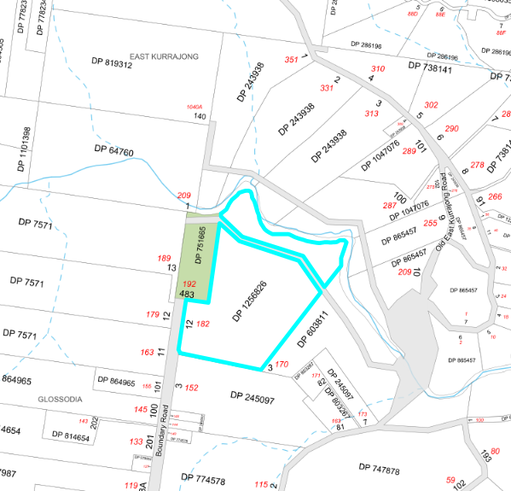
Figure 3: Locality Plan

The land varies in height from approximately 12 metres above Australian Height Datum (AHD) to 37 metres AHD. The lowest part of the land is located along the Howes Creek boundary and the highest part of the land is generally in the middle of the site where the existing mushroom farm buildings are located.

The predicted 1-in-100 year flood level for the locality is 13 metres AHD and applies to part of the land north of the road reserve intersecting the land.

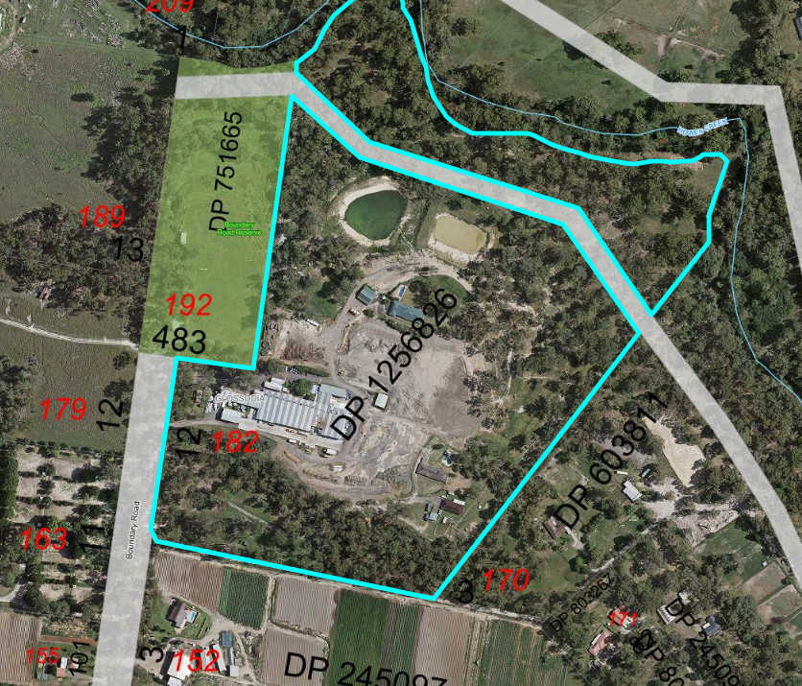
Figure 4: Aerial Photograph

The land is surrounded by a variety of rural residential uses and agricultural activities, including:

- Crown land reserve the northwest which is managed by Hawkesbury Council and currently leased to the Hawkesbury Valley Pony Club.
- Animal establishments for the keeping of horses to the east and west.
- Market garden to the south.

Development History

The original mushroom farm was approved by Council under Development Consent No. D0118/89 on 14 July 1989. This consent approved the construction of the mushroom farm in multiple stages which has been modified over time via subsequent approvals and modification applications since the issue of the original consent

Development Consent No. DA0820/15 is the latest consent relating to the existing mushroom farm and proposed a major expansion of the mushroom farm to upgrade existing buildings on site and support the mechanisation of the mushroom growing and picking process which has evolved along with new technologies. This application was considered and determined by the Joint Regional Planning Panel (JRPP) as the development has a Capital Investment Value (CPI) in excess of $20 million at the time the application was considered.

History of the Modification Application

04 September 2020 Application lodged.

17 September 2020 Planning Panel initiated after being referred to by Council under Clause 123BA of the Environmental Planning and Assessment Regulation 2000.

September 2020 Application advertised and notified from 8 October until 22 October 2020.

12 October 2020 Applicant requested to pay notification and advertising fees for the development.

October 2020 Four submissions received in relation to the proposal.

18 December 2020 Detailed assessment carried out and the applicant was requested to address matters in relation to consistency with plans, proposed hardstand area, the Biodiversity Conservation Act 2016, Flora and Fauna impacts, potential koala habitat, parking spaces, onsite manoeuvring, acoustic impacts, conditions of consent, waste storage and issues raised in response to public submissions.

1 March 2021 Site inspection with applicant carried out to explain matters raised in Councils letter of 18 December 2020.

18 March 2021 Correspondence sent to the applicant confirming matters which were discussed on site in relation to plans, landscaping, use of hardstand areas, truck movements, ecology and status of dwellings on site.

1 April 2021 Applicant advised that maters raised in Councils letter of 18 December 2020 need to be resolved. Additional time needed to address issues and provide amended plans.

The receipt of amended plans/determination of the application was placed on hold as amended plans were being prepared and a recent judgment in the Court of Appeal (AQC Dartbrook Management Pty Ltd v Minister for Planning and Public Spaces [2021] NSWCA 112) found that there is no power, either express or implied, to amend a modification application.

14 July 2021 New provisions introduced into the EP&A Regulation 2000 including clause 121B which provides that an application for modification of a development consent may, with the agreement of the consent authority, be amended by the applicant at any time before the application is determined.

15 July 2021 Applicant requested to provide an update concerning the additional information requested as part of the assessment of the proposal.

28 July 2021 Applicant submitted amended information.

Council Policies, Procedures and Codes to which the matter relates

State Environmental Planning Policy (State and Regional Development) 2011 (SRD SEPP)
State Environmental Planning Policy (Coastal Management) 2018 (Coastal Management SEPP)
State Environmental Planning Policy No. 33 – Hazardous and Offensive Development (SEPP No. 33)
State Environmental Planning Policy No. 55 – Remediation of Land (SEPP No. 55)
State Environmental Planning Policy 2021 (Koala Habitat Protection)
Sydney Regional Environmental Plan No. 20 – Hawkesbury-Nepean River (SREP No. 20)
Hawkesbury Local Environmental Plan 2012 (LEP)
Hawkesbury Council Development Control Plan 2002 (DCP)

Matters for consideration under the Biodiversity Conservation Act 2016

The original development application was submitted before 25 November 2019 and the provisions of this Act did not apply at the time as the land was declared by the Minister for the Environment as being within an Interim Designated Area. As part of the modification application the applicant has confirmed that:

- the land is not mapped on the Biodiversity Values Map published by the NSW Office of Environment and Heritage; and
- the proposed tree removal is below the area clearing threshold for the land.

Consequently the application is acceptable having regard to the Biodiversity Conservation Act 2016.

Matters for consideration under Section 4.55 of Environmental Planning and Assessment Act 1979 (EP & A Act)

Pursuant to Section 4.55 (2) of the EP&A Act 1979, the consent authority may modify the development consent if:

- it is satisfied that the development to which the consent as modified relates is substantially the same development as the development for which consent was originally granted and before that consent as originally granted was modified (if at all), and

Comment: The development remains for the purposes of major extension to the existing mushroom farm. The proposed changes have been clearly detailed in the amended plans and seek to improve the overall operation and layout of the development originally approved. The inclusion of additional buildings, services and amenities does not result in any significant change to the character or nature of the development and remains consistent with the existing approved use of the land.

The proposal is considered to be substantially the same as approved.

- it has consulted with the relevant Minister, public authority or approval body (within the meaning of Division 4.8) in respect of a condition imposed as a requirement of a concurrence to the consent or in accordance with the general terms of an approval proposed to be granted by the approval body and that Minister, authority or body has not, within 21 days after being consulted, objected to the modification of that consent, and

Comment: The proposal is not nominated as integrated development and the original consent is not subject to a condition of consent imposed by a public authority, approval body or the local planning panel.

- it has notified the application in accordance with—

- the regulations, if the regulations so require, or
- a development control plan, if the consent authority is a council that has made a development control plan that requires the notification or advertising of applications for modification of a development consent, and

Comment: The application has been notified in accordance with Councils DCP.

- it has considered any submissions made concerning the proposed modification within the period prescribed by the regulations or provided by the development control plan, as the case may be.

Subsections (1) and (1A) do not apply to such a modification.

Comment: Four submissions have been received in relation to this modification application and have been considered as part of the assessment report below.

In determining an application for modification of a consent, the consent authority must take into consideration such of the matters referred to in section 4.15(1) as are of relevance to the development the subject of the application. This assessment has been undertaken in the report below.

The consent authority must also take into consideration the reasons given by the consent authority for the granting of the consent that is sought to be modified. The reasons for the decision of the Panel were:

- The proposed development will add to the production of agricultural foodstuffs within the Sydney Basin and the Hawkesbury Local Government Area for a site zoned to permit intensive plant agriculture. The proposal will also generate additional rural employment.

- The panel has considered the applicants request to vary the development standard contained in Clause 4.3 (Height of Buildings) Hawkesbury LEP 2012 and considers that compliance with the standard is unreasonable and unnecessary in the circumstances of this case as the proposed variation will not generate unacceptable impacts on adjoining or nearby allotments, remains consistent with the objectives of the standard and will facilitate a building responding to the sloping nature of the subject site with internal dimensions required to conduct the proposed use.

- The proposed development adequately satisfies the relevant State Environmental Planning Policies including SEPP 55 Remediation of Land, SEPP 44 – Koala Habitat Protection and State Regional Environmental Plan No. 20 Hawkesbury-Nepean River (No. 2 1997).

- The proposal adequately satisfies the provisions and objectives of Hawkesbury LEP 2012 and Hawkesbury DCP 2002.

- The proposed development, subject to the conditions imposed, will have no unreasonable adverse impacts on the natural or built environments including the natural drainage system, the local ecology, the amenity of dwellings arising from odour, noise emissions and vehicle movements or on the operation of the local road system.

The proposed modification application remains consistent with the reasons given to the granting of the consent.

Matters for Consideration under Section 4.15 of the Environmental Planning and Assessment Act 1979

In determining the application, Council is required to take into consideration the following matters as are relevant to the development that apply to the land to which the development application relates:

a) The provisions (where applicable) of any:

i. Environmental Planning Instrument:

State Environmental Planning Policy (State and Regional Development) 2011 (SRD SEPP)
Schedule 7 (Regionally significant development) identifies general development over $30 million as regionally significant development. Whilst the proposal has an estimated capital value of $27,781,735.00 the original consent was determined by the planning panel when development over $20 million was identified as regionally significant development.

Clause 123BA of the Environmental Planning and Assessment Regulation 2000 does not allow Council to modify an application determined by the panel pursuant to 4.55(2) of the Act.

State Environmental Planning Policy (Coastal Management) 2018 (Coastal Management SEPP)
There are no specific requirements of this plan that would apply to the modification proposal and the land is not mapped as containing “coastal wetlands” or “proximity area for coastal wetlands” under this policy.

State Environmental Planning Policy No. 33 – Hazardous and Offensive Development
The modification application does not seek to change storage of LPG, diesel and chemicals onsite for the operation of machinery and equipment associated with the running of the farm. The application does not propose to change the location, quantity or storage of goods as part of this application.

Consequently the proposal would not result in the development being identified as either ‘potentially hazardous industry’ or ‘potentially offensive industry’ as the proposal would not alter the storage thresholds of materials onsite that would necessitate the need for the submission of a multi-level risk assessment.

State Environmental Planning Policy No. 55 – Remediation of Land (SEPP No. 55)
The modification application does not propose a change in land use from what was previously considered and approved and the matters concerning remediation of the land and suitability of the site remain unchanged.

The proposed new machinery shed is located in a part of the site covered in remnant vegetation and there is no evidence to suggest that this part of the land has been used for any activities that would raise a concern in relation to potential contamination. On this basis the proposal is considered acceptable having regard to the matters for consideration of this policy.

State Environmental Planning Policy 2021 (Koala Habitat Protection)
The modification application seeks to remove six trees in order to accommodate the proposed new machinery storage building. The flora and fauna assessment report accompanying the application confirms that whilst the trees proposed to be removed are listed as koala feed species under Schedule 2 the subject site is not considered to be core koala habitat for the purposes of the SEPP.

Therefore the proposal is considered to be acceptable having regard to the requirements of this policy.

Sydney Regional Environmental Plan No. 20 – Hawkesbury-Nepean River (SREP No. 20)
The modified proposal is not contrary to the aims, objectives and recommended strategies of SREP No. 20. The site is not within a scenic corridor of local or regional significance and the changes are not expected to significantly impact on the environment of the Hawkesbury-Nepean River in either a local or regional context.

The application is supported by a revised Stormwater Management Report which confirms that the proposed modifications to the development, including staging, will be able to achieve compliance with water quality and quantity requirements.

Hawkesbury Local Environmental Plan 2012 (LEP)
The land is zoned RU1 Primary Production and the proposed use is permissible in the zone with consent being identified as Intensive plant agriculture under Hawkesbury Local Environmental Plan (LEP) 2012. Intensive plant agriculture means any of the following:

(a) the cultivation of irrigated crops for commercial purposes (other than irrigated pasture or fodder crops),
(b) horticulture,
(c) turf farming,
(d) viticulture.

The cultivation of mushrooms for commercial purposes fits within the above definition. The proposed changes to the hardstand areas, changes to amenities and storage areas, and addition of a machinery building are all considered to be ancillary to the use of the land for the purposes of intensive plant agriculture.

The changes proposed as part of this modification application remain consistent with the objectives of the RU1 Primary Production zone as the proposal would support the expansion of an existing agricultural use and the new structures/works have been located in areas that seek to minimise conflict with adjacent development and avoid significant impact on the natural environment.

An assessment of the modified proposal has been carried out in relation to the following specific clauses of the LEP.

Clause 4.3 Height of buildings
A 10m maximum building height standard applies to the land as shown on the Height of Buildings Map. The original consent considered and approved a variation to this standard under Clause 4.6 (Exceptions to Development Standards).

The deviation from the standard relates to the mushroom growing building and varies depending on the height of the fill and the height of the proposed roof pitch to the existing ground level immediately below.

The highest part of the building relates to the ridgeline of the building to be constructed as part of stage 3 adjacent to the eastern property boundary. This part of the building totals 15.72m above the existing ground level and results in a 57% deviation from the building height development standard.

The JRPP supported a variation to the maximum 10 metre height requirement and noted the following in the reasons for decision:

The panel has considered the applicants request to vary the development standard contained in Clause 4.3 (Height of Buildings) Hawkesbury LEP 2012 and considers that compliance with the standard is unreasonable and unnecessary in the circumstances of this case as the proposed variation will not generate unacceptable impacts on adjoining or nearby allotments, remains consistent with the objectives of the standard and will facilitate a building responding to the sloping nature of the subject site with internal dimensions required to conduct the proposed use.

The proposed changes to the mushroom growing building and associated fill height will result in the maximum height of the building changing from 15.72m to 13.3 metres at the ridgeline of the part of the building proposed at stage 3. The building will also be setback a further 3 metres (25.24m) from the closest property boundary.

The change will result in the building being closer to the maximum building height development standard of 10 metres and should be supported as it is more consistent with the objective of this clause.

Clause 4.6 Exceptions to development standards
Consent has already been granted vary the maximum building height development standard pursuant to this clause. An application to modify the consent is not required to be accompanied by a request to vary the building height.

Clause 6.1 Acid sulfate soils
An acid sulfate soils management plan is not considered necessary as the proposed new works are not likely to lower the watertable.

Clause 6.2 Earthworks
The earthworks associated with the proposed modification are considered acceptable having regard to the requirements of this clause.

Clause 6.3 Flood planning
Proposed works are located above the predicted 1 in 100 year flood level and the modified proposal does not raise any concerns regarding impacts on floodwaters or evacuation from the property.

Clause 6.4 Terrestrial biodiversity
The proposed development area is mapped as Significant Vegetation on the Terrestrial Biodiversity Map. An amended Flora and Fauna Assessment Report has been submitted with the application to consider the additional tree removal associated with the proposed machinery shed.

The Flora and Fauna Assessment Report confirms that the trees proposed to be removed are in poor condition and the impact on flora and fauna species are considered minimal due to the low value of habitat for removal.

It is noted that no changes are proposed to the Vegetation Management Plan endorsed for the site and existing conditions in relation to compensatory planting and landscaping existing on the consent.

Clause 6.7 Essential Services
The modified development will unlikely increase the need or demand for essential services to the site. It is noted that the proposed water tanks for firefighting purposes is required under the Building Code of Australia due to the size of the building and need to have a static water supply for the fire sprinkler system.

ii. Draft Environmental Planning Instrument that is or has been placed on exhibition and details of which have been notified to Council:

Draft State Environmental Planning Policy (Remediation of Land)
The Explanation of Intended Effect for the above draft SEPP was placed on exhibition from 31 January 2018 to 13 April 2018. The proposed new SEPP intends to update the current SEPP 55 requirements and add new classes of remediation works that require development consent.

The modified proposal has been considered under the current SEPP and considered to be acceptable as discussed above.

Draft State Environmental Planning Policy (Environment)
The Explanation of Intended Effect for the Environment SEPP was placed on exhibition between 31 October 2017 and 31 January 2018. The intent of the SEPP is to both simplify the planning rules and definitions for environmental areas and consolidate several existing planning policies including Sydney Regional Environmental Plan No. 20 - Hawkesbury-Nepean River (No 2—1997) in to one new SEPP.

The Draft SEPP does not propose to change matters required to be considered or permitted under the SREP No. 20 and the modified proposal is considered to be acceptable as discussed above.

iii. Development Control Plan applying to the land:

Hawkesbury Development Control Plan 2002
An assessment of the proposal against the relevant chapter of this Plan follows.

Part A Chapter 3 – Notification
The application was notified from 08/10/2020 to 22/10/2020 in accordance with the Hawkesbury DCP 2002. Four submissions were received raising objection to the proposal and are considered under the submission section of this report below.

Part C - Chapter 1 - Landscaping
An amended landscape plan has been provided confirming the landscaping requirements specified in the consent, incorporating the new machinery shed and building modifications and showing additional planting is proposed along the embankments of the filled platform in order to improve the screening of the development.

The six trees proposed to be removed will be required to be replaced by the same number or more as specified in the existing condition of consent.

Existing landscaping between parking spaces and property boundaries will be retained.

Part C Chapter 2 – Car parking and Access
There are no specific parking requirements for agricultural uses/mushroom growing facilities.

The application is supported by a new Parking and Traffic Impact Statement which considerers the parking demand of the farm associated with the new staging of the development and number of staff associated with the proposed increase in mushroom production.

This has resulted in the need to provide a total of two additional parking spaces than what was originally approved and will be provided as follows:

- A total of 79 Staff/Visitor spaces and 1 accessible car space for stage 1
- A total of 93 spaces as part of stage 2
- A total of 104 spaces as part of stage 3

The application adequately justifies that sufficient parking would be provided for the development.

As part of the assessment of the proposal the applicant submitted a plan highlighting truck movements throughout the site will be consistent with what was originally considered and approved with the existing consent.

Conditions in respect to parking dimensions, access, aisle widths and mobility access are already included as part of the approved conditions of consent.

Part C Chapter 4 - Sediment erosion and Sediment control
Existing conditions of consent in relation to sediment and erosion matters will not be required to be modified as part of the proposed changes.

Part C Chapter 7 - Effluent disposal
Effluent disposal from the new amenities will be directed to an approved onsite effluent disposal system. Existing conditions of consent in relation to the management of sewerage onsite will not be required to be modified as part of the proposed changes.

Part C Chapter 8 - Management of construction and demolition waste
Existing conditions of consent in relation to the management of construction and demolition waste will not be required to be modified as part of the proposed changes.

Part D Chapter 6 - Dam construction
An updated stormwater management plan has been submitted demonstrating that the dams will be able to accommodate the proposed new buildings, layout and hardstand areas. Existing conditions of consent are not required to be modified in this regard.

Part D Chapter 8 - Farm Buildings and Outbuildings
This chapter specifies general requirements for farm buildings which are ancillary to agricultural land uses, however does not specify any particular requirements in relation to large scale mushroom/commercial farming buildings and associated ancillary buildings.

The modification will result in a reduction in overall building floor area and building height.

The proposed new/modified ancillary farm buildings are considered to be generally acceptable having regard to the requirements of this chapter and the overall character of the existing and approved development.

In this regard, all ancillary buildings have been clustered in one location of the site in order to minimise impacts on adjacent land uses and provides adequate setback from the street and adjoining neighbours (Figure 5).

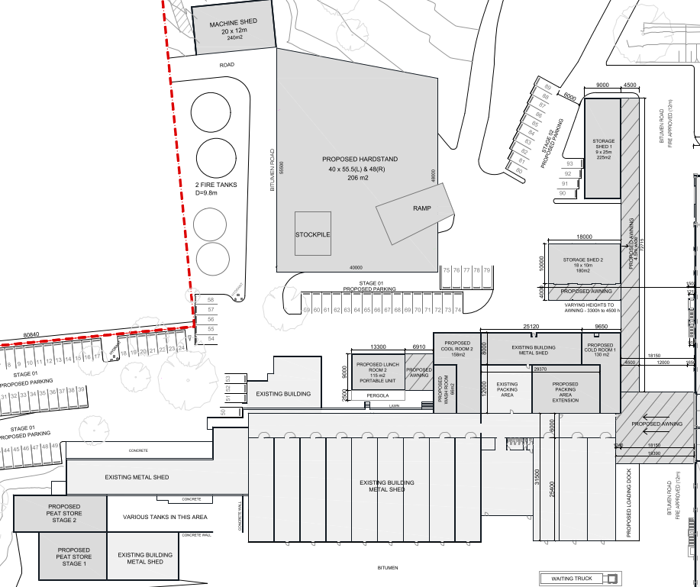

Figure 5: Ancillary buildings and hardstand areas.

The new machinery building to the north of the sire will not result in any adverse visual or amenity impact on the adjacent Crown land reserve to the western property boundary given the size and nature of the proposed building.

iiia. Planning agreement that has been entered into under section 7.4, or any draft planning agreement that a developer has offered to enter into under section 7.4:

Nil.

iv. Matters prescribed by the Regulations:

In accordance with the Environmental Planning and Assessment (EP&A) Regulation 2000 the development would be required to comply with The National Constriction Code – Building Code of Australia (BCA). Existing conditions are included in the consent.

b) The likely impacts of that development, including environmental impacts on both the natural and built environments and the social and economic impacts in the locality:

The modified proposal is unlikely to result in any additional adverse environmental or social impacts on the locality than what was previously considered and approved by the Joint Regional Planning Panel.

In general the form, scale and positioning of the proposed new building alterations, additions and ancillary structures and water tanks are consistent with existing structures onsite and the approved expansion of the mushroom farm.

The changes to the mushroom growing building will result in a reduction in building height and increased setback from the nearest property boundary. This is expected to have a positive impact in terms of visual appearance and the change to wall height will not result in any adverse impacts in terms of overall bulk and scale.

Revised acoustic, traffic, stormwater and flora and fauna reports accompany the proposed modification application and adequately consider the impacts of the proposed changes.

In order to reduce the potential impacts associated with the modification application the application has specified:
- Additional vegetation planting along property boundaries,
- Construction of a 2.4m high acoustic lapped and capped timber fence in accordance with the revised acoustic assessment report,
- Additional onsite parking,
- Increased manoeuvring areas for delivery and removal of products, waste and resources, and
- Pale eucalypt or olive green walls for the proposed insulated buildings.
- Green walls for non-insulated buildings,
- Zincalum roofs to match with existing buildings,

The increase in production is not expected to result in any significant impact in terms of traffic, hours of operation, servicing, staffing or amenities.

Support of the proposed changes will provide the consent holder with the opportunity to:
- make adjustments to the overall efficiency, function and layout of the mushroom farm,
- increase production by two tonnes per week on the completion of stage 3,
- stage the development so that the largest expansion will occur as part of stage 3, and
- adopt the latest up-to-date mushroom growing and picking technology.

c) Suitability of the site for the development:

The site is considered to be suitable for the development with sufficient area and access to services available to support the proposed modifications.

The suitability of the site to support extensions and alterations to the existing Mushroom farm was determined as part of the original approval and it is considered that the proposed changes do not materially change the suitability of the site for the proposed land use and development.

d) Any submissions made in accordance with the Act or the Regulations:

Public Submissions
Four submissions were received following the notification of the modified proposal and the issues raised in the submissions have been considered and assessed below.

- The application was originally approved on the basis that the mushroom facility would be built in stages and growth would depend on the demand for mushrooms in the future. It was also considered that the development will mean more jobs even though the farm will be an automated facility.

Comment: The original consent was approved for a number of reasons including permissibility and suitability of the development having regard to planning controls which apply to the development. It is noted that that:
- no conditions exist on the consent in relation to the timing of each stage,
- whilst the development seeks to automate the growing processes the development will generate employment for workers, including administration, deliveries, mushroom packing/pickers, building/site maintenance, construction work, truck drivers and other support services.

- The panel approved the consent even though there were strong objections against the number of heavy vehicles using Boundary Road which will impact the safety of pedestrians and deterioration of the road condition.

Comment: The impacts and suitably of the road were considered as part of the original assessment. An assessment of the proposed modification application has been carried out and it is considered that the changes will not have any adverse negative impact.

The applicant has confirmed that the traffic movements are the same as the approved development and will not rely on using Old East Kurrjaong Road as referred to in the submission.

The amended traffic report submitted confirms a total of approximately 97 truck movements to the site over a weekly period at an average of 2-3 trucks per hour, upon the completion of stage 3.

- The size of the buildings approved is significant and one of the main reasons the development was originally objected to.

Comment: The proposed modifications will result in a reduction in the maximum height and minimum setbacks associated with larger mushroom growing buildings as detailed previously in this report. The smaller ancillary structures have been clustered with existing buildings and are consistent with the existing form, scale and character of the mushroom farm.

- It is unclear as to what stage the current development is at and who is monitoring each stage.

Comment: The works carried out to date relate to the earthworks approved as part of stage 1 and 2 of the original consent and Council has issued a design compliance certificate which covers the civil works. The applicant is responsible for ensuring each stage is completed in accordance with any approval documents and the certifier monitors the construction works.

- This is not a modification and is a large scale change development.

Comment: The application seeks to modify the large scale development already approved on the site and the proposal is considered to be a modification pursuant to S4.55(2) of the EP&A Act as detailed in the assessment report above.

- Increased traffic will result in impacts on residents in terms of noise, dust, damage to the condition of existing roads and amenity of the area. Traffic will also impact wildlife.

Comment: Existing conditions are included in the consent which seek to minimise impacts on the amenity of the locality, particularly in relation to hours of operation, traffic, delivery vehicles, waste, and acoustic impacts.

It is acknowledged that whilst there is a concern in relation to potential traffic impact on wildlife, it is considered that this goes beyond the scope of what is required to be assessed having regard to the EP&A Act and there is no statutory requirement requiring the applicant or the determining authority to consider impacts of wildlife associated with the use of public roads.

- The proposal will increase odour impacts on the surrounding locality.

Comment: The impact of odour has been considered as part of the original assessment. It is noted that:
- mushroom compost imported to the site has already been processed at a separate facility and the odour impacts associated with the processing of compost occur before it is delivered to the site,
- compost being delivered to site is held within the proposed peat storage rooms or transported directly into the growing rooms,
- the locality is surrounded by a number of other land uses such as market gardens and turf farms which can contribute to local impacts in terms of odour,
- existing conditions of consent are imposed on the development to ensure the spent mushroom compost is removed from the site as soon as possible once removed from the growing rooms.

- The proposal will increase water runoff from the site and impact existing flooding, surface and grown water.

Comment: The site naturally drains to Howes Creek to the north which is subject to localised flooding during a heavy rain event and flooding from the Hawkesbury River. No works are proposed on land below the predicted 1 in 100 year flood level and the development has been designed to incorporate new water management techniques for the entire site in order to:
- recycle and treat water from proposed hardstand and roof areas,
- control water quality and quantity before entering or leaving the proposed dams, and
- minimise any impacts on downstream properties in a significant rain event.

An updated stormwater management plan has been submitted for the modified design and suitable conditions are included in the consent in relation to water management and ongoing quality monitoring.

- Increased noise impact

Comment: The proposed modifications are unlikely to increase noise impacts from what was originally considered and approved and suitable conditions are included in the consent to ensure noise, operating hours and acoustic measures are implemented as part of the construction and operation of the development.

- The modification application is the first time new neighbours have been notified of the development which plans major additions to the existing mushroom farm and insufficient time has been provided to review the proposal.

Comment: The original application was notified in accordance with the regulations and details of this approval history are available to view on Council’s application tracking system on the website. The modification application has been notified in accordance with the DCP and the consent authority is limited to assessing the proposed modifications sought. This application is not for a review of determination.

- The proposal will decrease property values

Comment: Impacts on property values are not a planning matter of consideration under S4.15 of the EP&A Act.

e) The Public Interest:

The proposed development is considered to be in the public interest based on the following:
- The proposal is acceptable having regard to the relevant environmental planning instruments applying to the land,
- The proposal is acceptable having regard to the objectives and requirements of the DCP,
- The issues raised in the submissions have been considered and do not warrant refusal of the proposal, and
- The modified proposed development is not expected to adversely impact the amenity of the locality or the surrounding environment from what was previously considered and approved on the land.

Development Contributions

Council’s Section 94A Contribution Plans applies to the development and condition 26 identifies the need to pay contributions at each stage of the development based on the estimated cost of each stage. This condition is not required to be modified as part of the proposed modification.

Integrated Approvals

The application has not been nominated as integrated development. The original consent approved the use of water storage facilities for a combination of purposes including onsite stormwater detention, water collection, water treatment and recycling. An existing condition of consent requiring the applicant to obtain any necessary water supply works under the Water Management Act 2000 is imposed. It is noted that the applicant has since received confirmation from Water NSW confirming that a water access licence is not required.

External Agency Referrals

The proposal is not required to be referred to external agencies for comment or concurrence.

It is noted that proposal is not identified as ‘traffic generating development’ under the Infrastructure SEPP. The threshold for traffic generating development on local roads of any size or capacity is 200 or more motor vehicles. The traffic assessment report submitted estimates a total of 137 vehicles traveling to the site per day based on the maximum expected number of cars, vans and heavy vehicles. These figures assume a worst case scenario where all employees drive to the site following the completion of stage three.

Internal Council Referrals

The proposal was referred to Councils internal engineers, building surveyors, sewerage management officers and environmental health officers for comment. Existing conditions on the consent are considered acceptable and are not required to be modified, other than for the adoption of new plans and supporting documentation.

Conclusion

The application has been assessed in accordance with the provisions of the EP&A Act with all matters specified under Section 4.15(1) having been taken into consideration. The application has been able to sufficiently demonstrate that the land is suitable for the proposed development having regard to the planning controls applicable to the development, in particular

The environmental impacts anticipated with the proposal are those relating to built form, landscaping and operational impacts. The management of these impacts has been considered in this report and have been adequately addressed based on the information submitted with the application.

It is recommended that the proposal be supported subject to the modified list of conditions included in Attachment 5 to this report.

Recommendation

That the Sydney Western City Planning Panel, as the consent authority, approve S960074/20 which seeks to modify Development Consent - DA0820/15 - Intensive Plant Agriculture - Construction of growing rooms associated internal access roads, drainage, dam and tree removal.

Reasons for Decision

It is recommended that the Sydney Western City Planning Panel approve the proposal based on the following reasons:

- The proposal is acceptable having regard to the statutory requirements which apply to the development.

- The modified proposal is considered to be substantially the same development as the development for which consent was originally granted.

- The proposal was notified in accordance with the Hawkesbury Development Control Plan 2002. Submissions received raised concerns in respect to impacts on adjacent development, traffic, noise, scale of the development, property values, amenity of the locality, landscaping, water runoff and visual appearance.

These matters have been considered and the proposed modifications are unlikely to result in any adverse impacts on the locality than what has been previously considered and approved on the land subject to the development being carried out in accordance with the information submitted with the application and the conditions recommended in attachment 5 of this report.

Attachments

Attachment 1 – Plans and Supporting Documents
(Refer to NSW Planning Portal and Listed under recommended Condition No. 1 of Attachment 5)

Attachment 2 – Determination and Statement of Reasons for DA0468/15 Sydney West Joint Regional Planning Panel (JRPP No. 2015SYW147)
(Refer to NSW Planning Portal)

Attachment 3 – Plans Approved Under DA0468/15 (JRPP No. 2015SYW147)
(Refer to NSW Planning Portal)

Attachment 4 – Submissions
(Refer to NSW Planning Portal)

Attachment 5 – Recommended Modified Consolidated Conditions of Consent

Attachment 5 – Recommended Modified Consolidated Conditions of Consent

Condition added as part of Sydney West Joint Regional Planning Panel of 28 September 2016
(Ref No. 2016SYW0015)

- A landscape plan prepared by a suitably qualified person shall be submitted to and approved by the Manager, Development Services at Hawkesbury Council.

This plan must be approved prior to the issue of a design compliance certificate. The proposed Landscaping must screen building and operational areas at the southern and eastern property boundaries, and trees removed as a result of the development shall be replaced by the same number or more.

Landscaping shall comprise of a combination of trees and shrubs endemic to the locality, this must be prepared in conjunction with the Vegetation Management Plan.

All screening landscaping on the land that is not to be filled shall take place in stage 1 of this consent.

General Conditions

- The development shall take place generally in accordance with the stamped plans, specifications and accompanying documentation listed below submitted with the application except as modified by these further conditions.

- Drawing No. DA-1002 – Overall Site Plan Stage 1, revision I, 17 December 2015
- Drawing No. DA-1003 – Overall Site Plan Stage 2, revision I, 17 December 2015
- Drawing No. DA-1004 – Overall Site Plan Stage 3, revision I, 17 December 2015
- Drawing No. DA-1500 – Proposed Overall Floor Plan, revision I, 17 December 2015
- Drawing No. DA- 2001 – Proposed Carton Store Floor Plan, revision H, 15 October 2015
- Drawing No. DA-2002 – Proposed Carton Store Elevations, revision H, 15 October 2015
- Drawing No. DA-2003 – Proposed Amenities Lunch Room, revision H, 15 October 2015
- Drawing No. DA-2004 – Peat Store Floor Plan, revision H, 15 October 2015
- Drawing No. DA-2005 – Peat Store Elevations, revision H, 15 October 2015
- Drawing No. DA-3000 – Landscaping Plan Concept, revision I, 17 December 2015
- Drawing No. 01 – Foundation Plan, revision 2, 11 March 2015
- Drawing No. 02 – Ground Floor Plan, revision 2, 11 March 2015
- Drawing No. 03 – Ceiling/first Floor Plan, revision 2, 11 March 2015
- Drawing No. 04 – Roof Plan, revision 2, 11 March 2015
- Drawing No. 10 – Elevations, revision 2, 11 March 2015
- Drawing No. 20 – Full Height Sections Sheet 1, revision 2, 11 March 2015
- Drawing No. 21 – Full Height Sections Sheet 2, revision 2, 11 March 2015
- Acoustic Impact Assessment, Project No. 215 035, prepared by PKA Acoustic Consulting, dated October 2015.
- Bushfire Safety and Evacuation Plan, B2015-013, prepared by Dialla Design Drafting Services, dated September 2015.
- Flora and Fauna Assessment report, prepared by Fraser Ecological Consulting, dated 6th December 2015.
- Onsite Wastewater Management Report, ref -183715-A, prepared by Envirotech Environmental and Engineering Consultancy Services, dated 26 October 2015.
- Parking and Traffic Impact Study, 15-070, prepared by Thompson Stanbury Associates, dated August 2015.
- Stormwater Management Report, SY150051, prepared by Barker Ryan and Stuart, dated December 2015.
- BCA Compliance Report, prepared by Urban City Consulting, dated December 2015.
- Concept Drainage Design Plans , Plan Set Number PSY15051 – Revision C, Sheets 1 to 8 Dated 03 December 15, prepared by Barker Ryan and Stuart.

Approved Plans and Supporting Documentation

The development must be carried out generally in accordance with the approved plans and supporting documentation listed below which have been endorsed by Council's approved stamp, except where amended in red on the plans and/or amended by other conditions of consent:

- Plans Reference:

Drawing Name | Prepared by | Drawing Number | Date
Cover Sheet | Noble Spaces | Drawing No. DA-1000, revision T | 08/06/2021
Existing Site Plan | Noble Spaces | Drawing No. DA-1001, revision T | 08/06/2021
Overall Site Plan -  Stage 1 | Noble Spaces | Drawing No. DA-1002, revision T | 08/06/2021
Overall Site Plan -  Stage 2 | Noble Spaces | Drawing No. DA-1003, revision T | 08/06/2021
Overall Site Plan -  Stage 3 | Noble Spaces | Drawing No. DA-1004, revision T | 08/06/2021
Proposed Overall Floor Plan | Noble Spaces | Drawing No. DA-5000, revision T | 08/06/2021
Proposed Overall Floor Plan – S3 | Noble Spaces | Drawing No. DA-1501, revision T | 08/06/2021
Parking Area and Cold Room Floor Plan | Noble Spaces | Drawing No. DA-2001, revision R | 17/11/20
Parking Area and Cold Room Elevations | Noble Spaces | Drawing No. DA-2002, revision R | 17/11/20
Lunch Room Elevation | Noble Spaces | Drawing No. DA-2002B, revision B | 04/02/2020
Storage Shed 1 | Noble Spaces | Drawing No. DA-2003, revision R | 08/06/2021
Peat Store Floor Plan | Noble Spaces | Drawing No. DA-2004, revision Q | 04/02/2020
Storage Shed 2 | Noble Spaces | Drawing No. DA-2005, revision Q | 04/02/2020
Machine Shed | Noble Spaces | Drawing No. DA-2006, revision Q | 04/02/2020
Proposed Overall S3 - Section | Noble Spaces | Drawing No. DA-2007, revision A | 08/06/2021
Landscaping Plan – Concept | Noble Spaces | Drawing No. DA-3000, revision S | 08/06/2021
Extension Ground Floor Plan | Gtl Europe | Drawing No. E-01 | 3/10/2019
Extension Full Height Sections Sheet 1 | Gtl Europe | Drawing No. E-10 | 3/10/2019
Extension Elevations Sheet 1 | Gtl Europe | Drawing No. E-20 | 3/10/2019
Extension 3D views Sheet 1 | Gtl Europe | Drawing No. E-30 | 3/10/2019
Extension 3D views Sheet 1 | Gtl Europe | Drawing No. E-31 | 3/10/2019

- Document Reference:

Document Name | Reference | Prepared by | Date
Acoustic Impact Assessment (Section 4.55 modification) | ID:11536 R01v2 | PKA Acoustic Consulting | 24 August 2020
Bushfire Safety and Evacuation Plan | B2015-013 | Dialla Design Drafting Services | September 2015
Flora and Fauna Assessment | 172-182 Boundary Road Glossodia | Fraser Ecological Consulting | 6th December 2015
Flora and Fauna Assessment (Section 4.55 modification) | 172-182 Boundary Road Glossodia | Fraser Ecological Consulting | 23 April 2021
Onsite Wastewater Management Report | ref -183715-A | Envirotech Environmental and Engineering Consultancy Services | 26 October 2015
Parking and Traffic Impact Study | 15-070 | Thompson Stanbury Associates | August 2015
Parking and Traffic Impact Statement (Section 4.55 Application) | 15-070-1 | Thompson Stanbury Associates | 20 July 2020
Stormwater Management Report  (Section 4.55 Application) | SY150051 | Barker Ryan and Stuart | August 2020
BCA Compliance Report | 172-182 Boundary Road Glossodia | Urban City Consulting | December 2015
BCA Compliance Assessment Report  (Section 4.55 Application) | 1834- Rev B | Accurate Fire and Building Consulting | 14 July 2020
Concept Drainage Design Plans | Plan Set Number PSY15051 – Revision C Sheets 1 to 8 | Barker Ryan and Stuart | 03 December 15
Tree Planting Schedule  (Section 4.55 Application) | 172-182 Boundary Road Glossodia | Urban City Consulting | July 2021
Truck Movement Plan  (Section 4.55 Application) | 172-182 Boundary Road Glossodia | Urban City Consulting | July 2021

(Condition amended via Modification Application No. S960074/20, September 2021)

- The subdivision proposal described as part of the application does not form part of this consent and all land titles, being Lot 1 DP 603811 and Lot 2 DP 603811 must be consolidated into one lot. A plan of consolidation must be registered with the Land and Property Information Division of the Department of Lands prior to the issue of an interim Occupation Certificate for stage 1 of the development.

- Following the consolidation of Lot 1 DP 603811 and Lot 2 DP 603811 the dwelling located Lot 2 DP 603811 shall be restricted to being used for the purposes of a rural workers dwelling.

The rural workers dwelling shall only be used as a place of residence by persons employed on the mushroom farm, whether on a long-term or short-term basis.

- No excavation, site works or building works shall be commenced prior to the issue of an appropriate Construction Certificate.

- The building shall not be used or occupied prior to the issue of an Occupation Certificate.

- The development shall comply with the provisions of the National Code of Construction - Building Code of Australia.

- This development falls within the Sewerage Scheme controlled by Hawkesbury City Council. Therefore Hawkesbury City Council is the approving authority for all sewer works.

Prior to Issue of Design Compliance Certificate Stage 1, 2 and 3

- The applicant shall obtain appropriate water supply licences under the Water Management Act 2000 for the development prior to the issue of any design compliance certificate relating to the proposed water storage facilities.

- The applicant shall pay a Design Compliance Certificate fee and a Construction Compliance Certificate fee in accordance with Councils fees and charges when submitting Civil Engineering Plans to Council for approval.

- All earthworks on site must comply with the following:

- Topsoil shall only be stripped from approved areas and shall be stockpiled for re-use during site rehabilitation and landscaping.

- All disturbed areas are to be stabilised/revegetated, using a minimum 300mm surface layer of topsoil, as soon as practicable after the completion of filling works.

- Once the topsoil has been removed the natural batter should be suitably stepped, scarified or roughened to prevent slipping and the fill is to be keyed in to hold the toe of the fill batter in place.

- Where batters exceed a ratio of three horizontal to one vertical, retaining walls, stoneflagging or terracing shall be constructed.

- All fill within the site shall be placed in layers not exceeding 300mm thickness and compacted to achieve a minimum dry density ratio of 95% when tested in accordance with Australian Standard AS 1289: Methods of testing soils for engineering purposes unless otherwise specified.

- Filling shall comprise only uncontaminated virgin excavated natural material. Contamination certificates for all source material shall be provided to the Principal Certifying Authority prior to placing any fill on site.

Details satisfying the above requirements are to be submitted to the Principal Certifying Authority prior to the issue of the Design Compliance Certificate.

- Any retaining walls having a height exceeding 600mm proposed in conjunction with the development are required to be designed by a practicing structural engineer.

The design must be submitted to the Principal Certifying Authority prior to issue of the Design Compliance Certificate.

- Prior to the issue of the Design Compliance Certificate, the applicant must submit to and obtain the Certifying Authority approval of a Soil and Water Management Plan. The SWMP must take into account the requirements of Landcom’s publication Managing Urban Stormwater - Soils and Construction (2004) and shall contain but not be limited to:

- Clear identification of site features, constraints and soil types

- Management of the cumulative impacts of the development on the quality and quantity of surface water, including stormwater in storage, sedimentation basins and flooding impacts.

- Details of a strategy for phasing of construction works so that land disturbances are confined to areas of a manageable size and kept to a minimum.

- Erosion and sediment control plans for each phase of construction that provide site-specific management measures, including details of short and long-term measures to be employed to minimise soil erosion and the discharge of sediment to land and/or waters including the locations and capacities of sediment fencing/straw bales, temporary storage ponds, sediment filters, filter barriers and other controls.

- A strategy for progressive revegetation and rehabilitation of disturbed areas of earth as rapidly as practicable after completion of earthworks.

- The potential for heavy prolonged rainfall during construction to cause environmental impacts including water quality impacts.

- Identification of all potential sources of water pollution and a detailed description of the remedial action to be taken or management systems to be implemented to minimise emissions of these pollutants from all sources within the subject site.

- Procedures for the re-use, treatment and disposal of water from sedimentation basins.

- Construction of the dam is to be undertaken in accordance with the Dam Construction Chapter in the Hawkesbury Development Control Plan 2002.

Details satisfying the construction requirements are to be submitted and approved by the Principal Certifying Authority prior to the issue of the Design Compliance Certificate.

- All reasonable measures to minimise dust generated during construction are to be implemented. This includes but is not limited to:

- Clearly defined stop work thresholds whereby earthworks on site will be ceased. Thresholds must be provided that relate to velocity and direction of wind and relative humidity.

- Stabilisation of stockpiles.

- Definition of the maximum allowable height of stockpiles.

Dust Management Measures are to be provided to the Principal Certifying Authority prior to the issue of the Design Compliance Certificate.

- The development shall not create adverse impacts to neighbouring properties in relation to overland flow and must meet the following requirements:

- Water flowing from the property must not be redirected or concentrated to adjoining properties.

- Water flowing into the property from adjoining lots shall not be impeded or diverted.

- Water flow shall follow the natural flow directions without increasing velocity.

- Pipes under buildings shall be structurally designed to withstand all applied forces. Details to this effect shall be incorporated on the detailed drainage design that is submitted to the certifying authority for the Design Compliance Certificate.

- All pits deeper than 0.9 metres must be designed by a certified structural engineer and be in accordance with AS3600-2009. Pits deeper than 1.2 metres must have step irons and pits deeper than 1.8 metres are to be reinforced concrete. Details to this effect shall be incorporated on the detailed drainage design that is submitted to the certifying authority for the Design Compliance Certificate.

- All pits must have flush fitting grates. All pits larger than 600mm x 600mm are to be grated galvanised steel grid hinged and be heavy duty type where traffic loading is expected.

- A detailed drainage design of the site must be submitted and approved prior to the release of the Design Compliance Certificate. The detailed plan must:

- be generally in accordance with Drainage Design with Plan Set Number PSY15051 sheets 1 to 8, revision C1, Dated 03/12/15, prepared by Barker Ryan and Stuart,

- drain to the dams and/or dispersed on site,

- indicate the method of disposal of all stormwater and must include existing ground levels, finished surface levels, estimated flow rates, invert levels and sizes of all pipelines,

- be to the satisfaction of the Certifying Authority,

- be designed to cater for a 1 in 20 year Average Recurrence Interval storm event,

- show details of any overflow drainage paths and that they be designed to cater for 1 in 100 year Average Recurrence Interval storm event,

- comply with Council's Hawkesbury Development Control Plan (Part I & Chapter 8) and Australian Standard AS3500 – Plumbing and Drainage unless variation is specifically noted and approved on DA concept drainage plan.

- The vehicular usage of the site must be constructed to comply with the following requirements:

- All vehicles must be loaded and unloaded entirely within the property in a safe and practical manner.

- All vehicles shall be driven in a forward direction at all times when entering and leaving the premises.

- Vehicles entering and exiting the site must not create queuing which adversely affects vehicles travelling on the public road network.

Details showing Compliance with the above requirements are to be clearly demonstrated on plans prior to issue of a Design Compliance Certificate. In this respect loading and unloading areas are to be clearly designated and the swept paths of the longest vehicle entering and exiting the subject site in accordance with Australian Standard AS 2890.1 and AS 2890.2 shall be provided.

- All car parking areas, manoeuvring areas and the access aisles must be paved, drained and marked. The pavement must be designed by a qualified civil engineer and certified to be satisfactory for the expected traffic loadings. AUSTROADS Guide to Pavement Technology can be used as the design guideline for the pavement design.

The laybacks and crossings must be designed to accommodate expected traffic loadings. In this regard they must be constructed to a commercial/industrial standard with the work carried out at the Developer's expense, including all alteration to public infrastructure where necessary.

The above details must be incorporated on appropriate submitted plans prior to the issue of the Design Compliance Certificate.

Prior to Issue of Design Compliance Certificate Stage 1

- A standard industrial vehicular sealed driveway and crossing for the truck driveway must be constructed that complies with the following requirements:

- have a minimum width of 6m within the road reserve and within the property be wide enough to facilitate practical entry and exit in a safe manner,

- not interfere with the existing public utility infrastructure,

- be in accordance with Hawkesbury Council's Development Control Plan Appendix E.

Where there is conflict between the location of the proposed driveway and the assets of a service utility, such as Telstra pits/manholes, the relevant service provider must be contacted prior to any driveway works commencing. It is an offence to modify or tamper with the assets of a service provider. Details are to be provided on plans submitted to the certifying authority prior to issue of a Design Compliance Certificate.

- Car parking spaces shall be provided in accordance with Hawkesbury City Councils Development Control Plan and maintained on the land in accordance with the Approved Plans. Disabled car parking spaces shall be clearly marked and signposted for use by disabled persons. The disabled parking spaces are to conform with AS2890.6 Parking facilities: Off-street parking for people with disabilities.

The minimum number of spaces provided shall be as follows:

Stage 1
83 79- Staff/Visitor
1 - Accessible Car Space

The car parking spaces are to be identified on-site by line-marking. Details in accordance with the above must be submitted to the Principal Certifying Authority prior to issue of the Design Compliance Certificate.

(Condition amended via Modification Application No. S960074/20, September 2021)

- A standard sealed driveway and crossing for the employee driveway must be constructed that complies with the following requirements:

- have a minimum width of 6m within the road reserve and 6m within the property from the boundary to the start of the first car parking area,

- not interfere with the existing public utility infrastructure,

- be in accordance with Hawkesbury Council's Development Control Plan Appendix E.

Where there is conflict between the location of the proposed driveway and the assets of a service utility, such as Telstra pits/manholes, the relevant service provider must be contacted prior to any driveway works commencing. It is an offence to modify or tamper with the assets of a service provider. Details are to be provided on plans submitted to the certifying authority prior to issue of a Design Compliance Certificate.

Prior to Issue of Design Compliance Certificate Stage 2

- Car parking spaces shall be provided in accordance with Hawkesbury City Councils Development Control Plan and maintained on the land in accordance with the Approved Plans. Disabled car parking spaces shall be clearly marked and signposted for use by disabled persons. The disabled parking spaces are to conform with AS2890.6 Parking facilities: Off-street parking for people with disabilities.

The minimum number of spaces provided shall be as follows:

102 93 for stage 2 and 104 for stage 3 - Staff/Visitor
1 - Accessible Car Space

The car parking spaces are to be identified on-site by line-marking. Details in accordance with the above must be submitted to the Principal Certifying Authority prior to issue of the Design Compliance Certificate.

(Condition amended via Modification Application No. S960074/20, September 2021)

Prior to Issue of Construction Certificate Stage 1, 2 and 3

- Pursuant to Section 80A(1) of the Environmental Planning and Assessment Act 1979 development contribution fees for each stage of the development shall be paid to Hawkesbury City Council in accordance with Hawkesbury City Council’s Section 94A Development Contributions Plan 2015 (as amended from time to time).

A 1% levy applies to the development and will be calculated using the total estimated cost of works associated with each stage of the development. A cost summary report covering all the works associated with stage 1, 2 and 3 shall be prepared by a quantity surveyor who is a registered member of the Australian Institute of Quantity Surveyors and submitted to Council prior to the issue of any construction certificate.

The amount to be paid is to be adjusted at the time of the actual payment, in accordance with the provisions of Hawkesbury City Council’s Section 94A Development Contributions Plan 2015 (as amended from time to time).

The contribution is to be paid prior to the issue of the construction certificate and copies of receipt(s) confirming that the contribution has been fully paid are to be provided to the certifying authority.

- A Section 73 “Notice of Requirements” under the Sydney Water Act 1994 must be obtained from Sydney Water Corporation for each stage of the development.

Application must be made through an authorised Water Servicing Coordinator. Please refer to the Building Developing and Plumbing section of the web site www.sydneywater.com.au then refer to "Water Servicing Coordinator" under "Developing Your Land" or telephone13 20 92 for assistance.

Following application a "Notice of Requirements" will advise of water and sewer infrastructure to be built and charges to be paid. Please make early contact with the Coordinator, since building of water/sewer infrastructure can be time consuming and may impact on other services and building, driveway or landscape design.

- A Sewer Management Facility System application shall be submitted to Hawkesbury City Council for each stage of the development. Evidence of the approval of the application must be submitted to the Principal Certifying Authority prior to the issue of a construction certificate.

- As this development involves connection to an on-site sewerage treatment system, payment of the prescribed inspection fee for both internal and external sewer drainage work is required to be made to Hawkesbury City Council prior to the issue of a construction certificate for each stage of the development.

- Where retaining walls are proposed to be constructed over 600mm in height, the design must be certified by a suitably qualified person and must be supplied to the Principal Certifying Authority.

- A qualified Structural Engineer's design for all reinforced concrete and structural steel shall be provided to the Principal Certifying Authority prior to any works commencing on site.

- Access to the development for people with disabilities shall be provided in accordance with the Disability (Access to Premises – Buildings) Standards 2010. Details shall be provided to the Principal Certifying Authority prior to the issue of a Construction Certificate for building work.

- Specifications of the acoustic barrier referred to in the acoustic report, PKA Acoustic Consulting 215 035 RO1 v1-1 ID:11536 RO1v2 dated 24 August 2020 shall be provided to the Principal Certifying Authority prior to the issue of a Construction Certificate.

A suitably qualified acoustic consultant shall be engaged to assist with the preparation of the final building plans and specifications to ensure compliance with any acoustic conditions. Details demonstrating compliance with this requirement must be submitted to the Principal Certifying Authority prior to issue of the Construction Certificate.

The barrier is to be constructed to prevent light spillage on adjoining properties from vehicles using the loading dock.

(Condition amended via Modification Application No. S960074/20, September 2021)

- External colours/materials used in the building are to be selected so that glare impact upon adjoining properties is minimised. Details satisfying this requirement are to be submitted to the Principal Certifying Authority prior to the issue of the Construction Certificate.

Prior to Commencement of Works Stage 1, 2 and 3

- The applicant shall advise Council of the name, address and contact number of the Principal certifier in accordance with Section 81A 2(b) of the Environmental Planning and Assessment Act 1979.

- At least two days prior to commencement of works, notice is to be given to Hawkesbury City Council in accordance with the Environmental Planning and Assessment Regulation 2000.

- Toilet facilities (to the satisfaction of Council) shall be provided for workmen throughout the course of building operations. Such facility shall be located wholly within the property boundary.

- A sign displaying the following information is to be erected adjacent to each access point and to be easily seen from the public road. The sign is to be maintained for the duration of works:

- Unauthorised access to the site is prohibited.

- The owner of the site.

- The person/company carrying out the site works and telephone number (including 24 hour seven days emergency numbers).

- The name and contact number of the Principal Certifying Authority.

- All civil construction works required by this consent shall be in accordance with Hawkesbury Development Control Plan 2002 – Appendix E – Civil Works Specification. Inspections shall be carried out and compliance certificates issued by Council or an accredited certifier.

- The approved plans must be submitted to and endorsed by Sydney Water via the Sydney Water Tap in website to determine whether the development will affect Sydney Water's water mains, stormwater drains and/or easements, and if further requirements need to be met. Plans will be appropriately stamped.

Please refer to the web site http://www.sydneywater.com.au/tapin/index.htm or telephone 1300 082 746 Monday to Friday 8.30am to 5.30pm.

Evidence of the building plan approval must be forwarded to the Principal Certifying Authority prior to the commencement of works.

- A Traffic Control Plan prepared in accordance with the Roads and Maritime Services’ publication Traffic Control at Worksites is to be prepared by an appropriately qualified person and submitted to Council for approval, prior to commencement of any works within the road reserve.

- Prior to works commencing, documentary evidence shall be provided to the Principal Certifying Authority demonstrating that the proposed fill material is either:

- Uncontaminated virgin excavated natural material (VENM) as defined under the provisions of the NSW Protection of the Environment Operations Act 1997; or

- Excavated Natural Material (ENM) as defined by the Excavated Natural Material Exemption 2012 - NSW Environment Protection Authority. The material is from a known origin and composition, free of contamination from manufactured chemicals, process residues, building debris, sulfidic ores, or other foreign matter; or

- Fill which has been characterised and validated by a suitably qualified and experienced site contamination consultant, in accordance with the NSW Office of Environment and Heritage publication Contaminated Sites - Sampling Design Guidelines 1995.

Written details are to be kept of address of the origin of the fill; quantities, dates, and times of delivery from each location; registration numbers and driver’s identification details; and laboratory test results/consultants reports and available for inspection by the Principal Certifying Authority or Council upon receipt of a written request.

All fill shall be placed in accordance with the standards specified in Table 5.1 of Australian Standard AS 3798 - Guidelines on Earthworks for Commercial and Residential Developments.

- A detailed landscape plan shall be prepared and approved by the Principal Certifying Authority prior to the commencement of works. Native vegetation of local provenance shall be used for the landscaping works.

- Vegetation waste resulting from the approved clearing of the site shall be salvaged for re-use, either in log form, or as woodchip mulch for erosion control and/or site rehabilitation. Non-salvageable material such as roots, stumps or declared weed species shall be disposed of to an appropriate waste facility.

No vegetative material is to be disposed of by burning on-site other than in an approved heating or cooking device.

- The property entry and exit points shall be secured at all times to prevent the unauthorised entry of vehicles, and to ensure that the site manager can control and prevent dumping of waste and potentially contaminated material whilst fill material is being imported or managed on site.

During Construction Stage 1, 2 and 3

- Dust control measures, e.g. vegetative cover, mulches, irrigation, barriers and stone, shall be applied to reduce surface and airborne movement of sediment blown from exposed areas.

- Measures shall be implemented to prevent vehicles tracking sediment, debris, soil and other pollutants onto any road.

- The site shall be kept clean and tidy during the construction period and all unused building materials and rubbish shall be removed from the site upon completion of the project. The following restrictions apply during construction:

- Building operations such as brick cutting, washing tools, concreting and bricklaying shall be undertaken only within the site.

- Builders waste must not be burnt or buried on site.

- All waste (including felled trees) must be contained and removed to a Waste Disposal Depot.

- During the demolition and construction period, the person responsible for the site is to retain records of waste disposal (waste receipts or dockets, recycling processor receipts etc.) in a Waste Data File. The Waste Data File must be provided to Council officers on request to demonstrate that the approved Waste Management Plan is being implemented.

- At all times during demolition, a competent person shall directly supervise work. It is the responsibility of the person to ensure that:

- Adjoining owners are given 24 hours notice, in writing, prior to commencing demolition.

- Utility services within the structure not required to be maintained during the demolition work shall be properly disconnected and sealed before any demolition commences.

- The site shall be secured at all times against the unauthorised entry of persons or vehicles.

- Safe access and egress from adjoining buildings is to be maintained at all times for the duration of the demolition work.

- Precautions are taken to ensure that the stability of all parts of the structure and the safety of persons on and outside the site are maintained, particularly in the event of sudden and severe weather changes.

- The structure and all components shall be maintained in a stable and safe condition at all stages of the demolition work.

- Demolition activity shall not cause damage to or adversely affect the structural integrity of adjoining buildings.

- Removal of dangerous or hazardous materials shall be carried out in accordance with the provisions of all applicable State legislation and with any relevant recommendations published by the National Occupational Health and Safety Commission (Worksafe Australia).

- All works removing asbestos containing materials must be carried out by a suitably licensed asbestos revivalist duly licensed with WorkCover NSW, holding either a Friable (Class A) or a Non- Friable (Class B) Asbestos Removal Licence which ever applies.

- All work shall be carried out in accordance with AS2601.

- Unless otherwise permitted by Council, the structure is to be demolished in reverse order of construction, being progressive and having regard to the type of construction, to enable the maximum separation and recycling of demolished materials to take place.

- No material is to be burnt on site.

- All fuel storage tanks and LPG tanks are to comply with all NSW EPA and NSW SafeWork requirements. This is to include all setback and bunding requirements.

- Compliance certificates (known as Part 4A Certificates) are to be issued for Critical stage inspections as detailed in the Environmental Planning and Assessment Regulation 2000 as required by section 109E (3) (d) of the Environmental Planning and Assessment Act 1979 by the nominated Principal Certifying Authority.

- Inspections and Compliance Certificates for sanitary drainage works can be conducted and issued by Hawkesbury City Council. Inspections must be conducted on the exposed pipes prior to covering.

In the case of internal and external (house service connection) drainage, the inspection must be conducted by Hawkesbury City Council’s Building and Development Branch. Please phone (02) 4560-4565 to arrange inspections.

- No work can be undertaken within adjoining public lands (i.e. Parks, Reserves, Roads etc.) without the prior written consent of Council. The developer must bear the cost of all works associated with the development that occurs on Council’s property, and comply with the following requirements:

- Prior to issue of a Construction Certificate or approval under the Roads Act 1993 or Local Government Act 1993, a security bond of $10,000 is to be submitted to Council to guarantee the protection of the road pavement and other public assets in the vicinity of the site.

- The Bond is recoverable upon written application to Council on completion of the filling and construction works associated with each stage, subject to satisfactory restoration as required. Fees for the lodgement of the bond apply.

- A dilapidation survey and report (including photographic record) must be prepared by a suitably experienced person detailing the pre-developed condition of;

- The entire length of Boundary Road

- Spinks Road in the vicinity of the intersection with Boundary Road.

Particular attention must be paid to accurately recording any pre-developed damaged areas so that Council is fully informed when assessing any damage to public infrastructure caused as a result of the development.

The developer may be held liable for all damage to public infrastructure in the vicinity of the site, where such damage is not accurately recorded and demonstrated as pre-existing under the requirements of this condition.

A copy of the dilapidation survey and report must be lodged with Council by the Principal Certifying Authority prior to the issue of any Construction Certificate.

- Clearing of land, running of machinery, excavation, and/or earthworks, building works and the delivery of building materials shall be carried out between the following hours:

- between 7:00 am and 6:00 pm, Mondays to Fridays inclusive;

- between 8:00 am and 4:00 pm, Saturdays;

- no work on Sundays and public holidays;

- works may be undertaken outside these hours where:

- the delivery of vehicles, plant or materials is required outside these hours by the Police or other authorities;

- it is required in an emergency to avoid the loss of life, damage to property and/or to prevent environmental harm;

- a variation is approved in advance in writing by Council.

- The measures required in the Soil and Water Management Plan approved by the Certifying Authority must be implemented as a priority over general construction works. The controls must be maintained at all times during each stage of the development and checked for adequacy daily. The controls must not be removed until the development is completed and the disturbed areas have been stabilised.

Maintenance must include but is not limited to ensuring:

- all sediment fences, sediment traps and socks are properly placed and are working effectively and,

- drains, gutters and roads are maintained clear of sediment at all times.

Note: It is an offence under the Protection of the Environment Operations Act 1997 to allow soil or other pollutants to fall or be washed into any waters or be placed where it is likely to fall or be washed into any waters. Substantial penalties may be issued for any offence.

- All plant and equipment to be used or installed on the premises must comply with the vibration limits specified in Assessing Vibration: a technical guideline prepared by the NSW Environment Protection Authority, at the boundary of any affected receiver.

If requested by Council or the Principal Certifying Authority during Construction the applicant is to provide a vibration compliance letter from an appropriately qualified acoustic consultant eligible for membership of the Association of Australian Acoustic Consultants, certifying that all plant and equipment on the site, together with the proposed plant and equipment, operating simultaneously will comply with the requirements of this condition.

- Topsoil shall only be stripped from approved areas and shall be stockpiled for re-use during site rehabilitation and landscaping.

Stockpiles of topsoil, sand, aggregate, spoil or other material stored on the site that is capable of being moved by running water shall be stored clear of any drainage line or easement, natural watercourse, footpath, kerb, and/or road surface.

Suitable sediment and erosion control devices shall be installed prior to the stockpile being created. The stockpile shall be treated so its surface is erosion resistant to wind and water action.

- Vegetation removal shall be undertaken under the supervision and direction of a consulting ecologist. Where possible, escaped fauna is to be caught by the consulting ecologist and transported to a suitable release area.

- Planting shall be undertaken in accordance with the approved landscaping plan.

- A Vegetation Management Plan shall be prepared for the site and designed to protect vegetation onsite that is proposed to be retained and or planted out as part of the landscaping of the property. This plan shall be implemented at the beginning of stage 1 works.

Prior to Issue of Construction Compliance Certificate Stage 1, 2 and 3

- Prior to the issue of a Construction Compliance Certificate all works must be completed in accordance with approved Design Compliance Certificate, Approved Plans, associated correspondence and to the satisfaction of the certifying authority.

- Works As Executed plans must be submitted to the Certifying Authority by a registered surveyor certifying compliance with the approved design plans. The Works As Executed dimensions and levels must be shown in red on a copy of the approved Design Compliance Certificate plans. The plans must verify:

- surface level of constructed paved areas,

- surface and invert levels on all pits,

- invert levels and sizes of all pipelines,

- floor levels of all buildings and

- top of kerb levels at the front of the lot.

All levels must relate to Australian Height Datum.

Prior to issue of Occupation Certificate Stage 1, 2 and 3

- A Construction Compliance Certificate for all civil works shall be obtained and submitted to the Principal Certifying Authority prior to the issue of an Interim Occupation Certificate.

- An approval to operate the on-site septic system is required to be obtained from Hawkesbury City Council. The approval to operate is required to be submitted to the Principal Certifying Authority prior to the issue of an Interim Occupation Certificate.

- A Section 73 Compliance Certificate under the Sydney Water Act 1994 must be obtained from Sydney Water Corporation.

- Written clearance from Integral Energy shall be submitted to the Principal Certifying Authority.

- A written clearance from Hawkesbury City Council (as the local sewer authority) that the development is suitably connected to the on-site sewerage management system, is required to be submitted to the Principal Certifying Authority prior to the issue of an interim occupation certificate.

- Landscaping shall be completed as shown on the approved landscaping plan prior to the issue of a final occupation certificate.

Use Conditions

- All fire safety equipment and fixtures shall be regularly serviced and maintained. The owner or their agent shall certify annually that each of the fire safety measures specified in this statement has:

- been assessed by a properly qualified person, and

- found, when it was assessed, to be capable of performing to at least the standard required by the current Fire Safety Schedule for the building for which the certificate is issued.

- No internal or external alterations shall be carried out without prior approval of Council.

- The operation is to be conducted in accordance with the recommendations specified in the Acoustic Impact Assessment, Project No. 215 035 prepared by PKA Acoustic Consulting, dated October 2015. ID:11536 RO1v2 dated 24 August 2020.

(Condition amended via Modification Application No. S960074/20, September 2021)

- The hours of operation of the mushroom farm shall be limited to 6am to 10pm seven days a week with the exception of the use of the property between 10 to 12 midnight for four truck movements only.

- The following activities are to be conducted during daytime hours (7am to 6pm only);

- Trucks movements including delivery and removal of compost, pick up trucks for collection of mushroom and waste trucks.

- Peat mixing.

- The Operation of the outdoor spray wash area must be limited to 7am to 10pm.

- During the hours of 7am to 10pm, the development shall be managed so that the LAeq noise levels, measured at any point in accordance with the NSW DECs' Industrial Noise Source Policy, do not exceed 5dB(A) (LAeq) above background levels (LA90) with respect to noise amenity of residential properties and associated outdoor areas.

- Between the hours of 10pm to 7am, the development shall be managed so that the noise level does not create offensive noise when assessed against the NSW Government Office of Environment, Climate Change and Water, Noise Guide for Local Government document 2010.

- All doors and windows (including the large doors facing south and east) are required to be kept closed when the trucks are loading / unloading compost into the growing rooms.

- All runoff water and wash down water is to be captured and disposed of as specified in the Stormwater Management Plan.

- Quarterly water testing of the water from the washdown activities is to be conducted. A report is to be prepared and submitted to Hawkesbury City Council along with the water testing results showing the treated wash down water (samples taken along the treatment system after solid removal process, after the wetland system and then at the outlet of all dams) meets the appropriate standards / guidelines and is suitable for discharge.

- All discharge water from the cooling towers and boilers is to be collected and discharged into an approved treatment system. Details of the collection and disposal methods of wastewater must be provided to the satisfaction of the Principal Certifying Authority prior to commencement of use.

- Lights are to be located and directed in such a manner that adjoining and nearby properties are not impacted by light spillage.

- Any chemical containers are to be disposed of through an authorised waste disposal facility. Chemical containers are to be prepared for disposal in accordance with the Agsafe Standard for 'Effective Rinsing of Farm Chemical Containers'. Excess chemicals, herbicides or insecticides are to be disposed of through the "ChemClear" programme conducted by Agsafe (www.chemclear.com.au) or through other appropriate programs.

- The application, management and record keeping of pesticides at the premises must comply with the following legislation or guidelines:

- WorkCover NSW 1998 -"Code of Practice for the Safe use of and Storage of Chemicals (including pesticides and herbicides) in Agriculture";

- WorkCover "Code of Practice for the Labelling of Workplace substances

- NSW Department of Primary Industries "Spray Drift Management - Principles, strategies and supporting information";

- NSW Department of Primary Industries "Reducing herbicide spray drift".

- No burning of materials shall occur at the site.

- Used mushroom compost must be removed from the site as soon as possible once removed from the growing rooms. Stockpiles are stored in an appropriate location that does not interfere with neighbouring properties and away from watercourses.

Advisory Notes:

*** Private Accredited Certifiers do not have any authority to issue Engineering Approvals or carry out inspections for works on Public Roads under the Roads Act 1993.

*** The developer is responsible for all costs associated with any alteration, relocation or enlargement to public utilities whether caused directly or indirectly by this proposed development. Such utilities include water, sewerage, drainage, power, communication, footways, kerb and gutter.

*** Should any aboriginal site or relic be disturbed or uncovered during the construction of this development, all work should cease and the National Parks and Wildlife Service consulted. Any person who knowingly disturbs an aboriginal site or relic is liable to prosecution under the National Parks and Wildlife Act 1974.

*** The applicant is advised to consult with the relevant:

- water and sewer provider

- electricity provider

- natural gas provider

- telecommunications carrier

- road authority

regarding their requirements for the provision of services to the development and the location of existing services that may be affected by proposed works, either on site or on the adjacent public roads.

*** The applicant shall make themselves aware of any User Restriction, Easements and Covenants to this property and shall comply with the requirements of any Section 88B Instrument relevant to the property in order to prevent the possibility of legal proceedings against them.

*** Please contact Council’s Customer Service Staff to make an appointment so that Council officers may conduct an inspection of your on-site sewage management system so that it can be assessed for it suitability for the proposed development and so that a current approval to operate may be issued. The installed system will be the subject of an approval to operate a system of sewage management in accordance with the provisions of Subdivision 6 & 7 of Division 4 of Part 2 of the Local Government (General) Regulation 2005 and for this purpose will be subject to inspection at annual frequency by Council's Environmental Health Officer or at such other frequency as may be determined according to the future operation or risk of the system.

*** The development is not to contribute to water pollution or pollution of waters as defined in the dictionary to the Protection of the Environment Operations Act 1997.

